**How to create Data bricks**

Create a Databricks workspace.

Explore the UI without creating a compute (to avoid unnecessary charges).

Prepare for DBUTIL commands in the upcoming session.

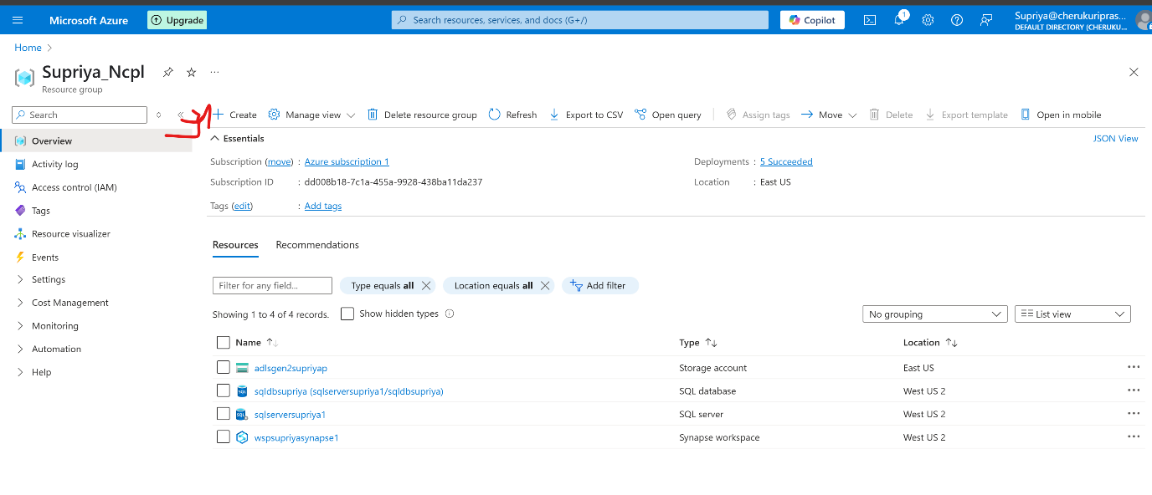

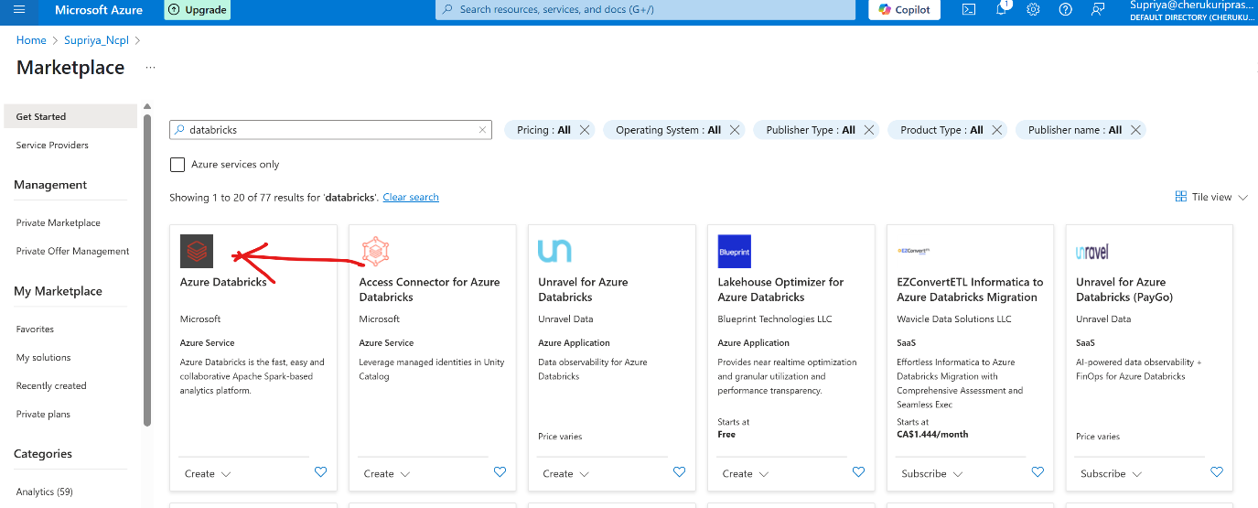

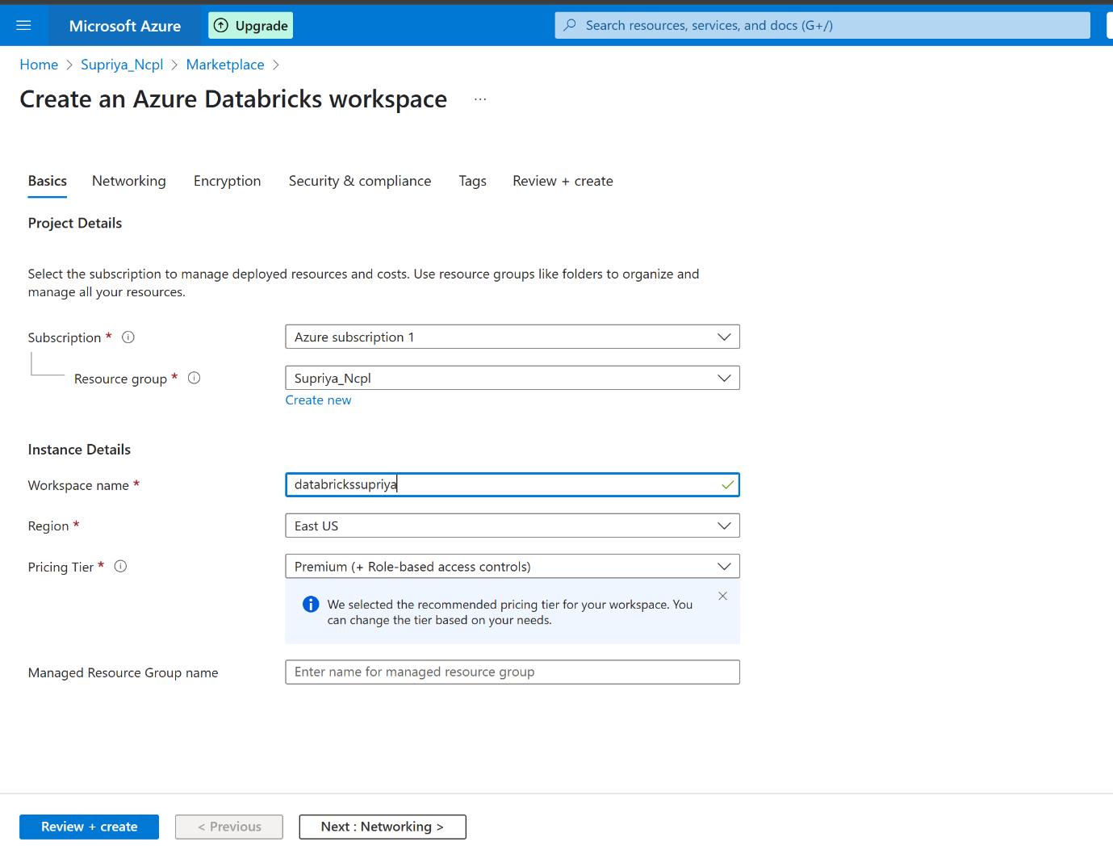

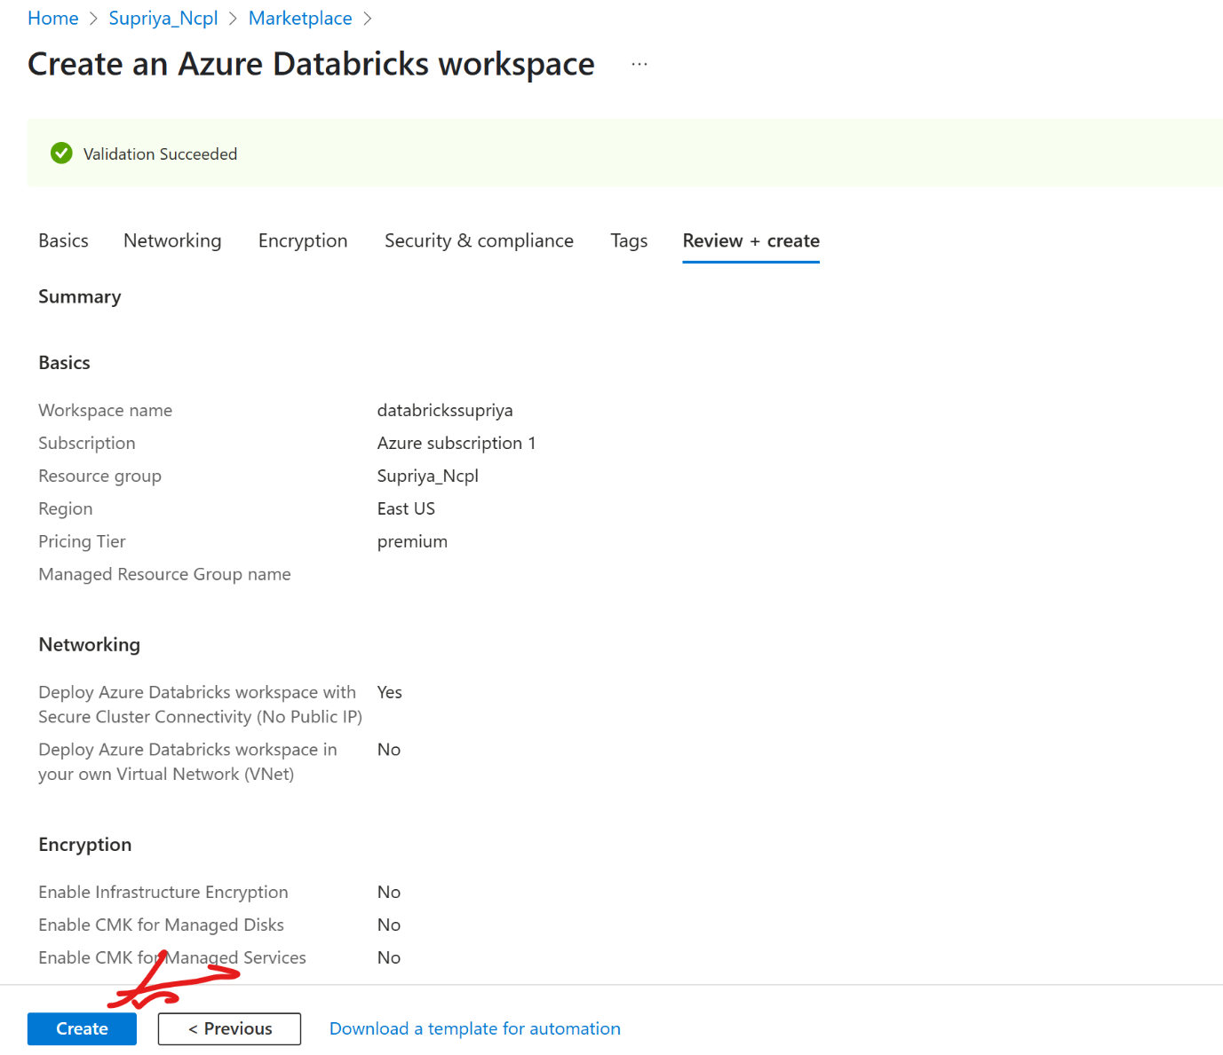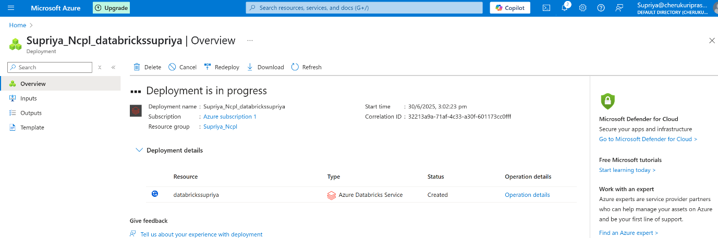

Click on launch to open in new page.

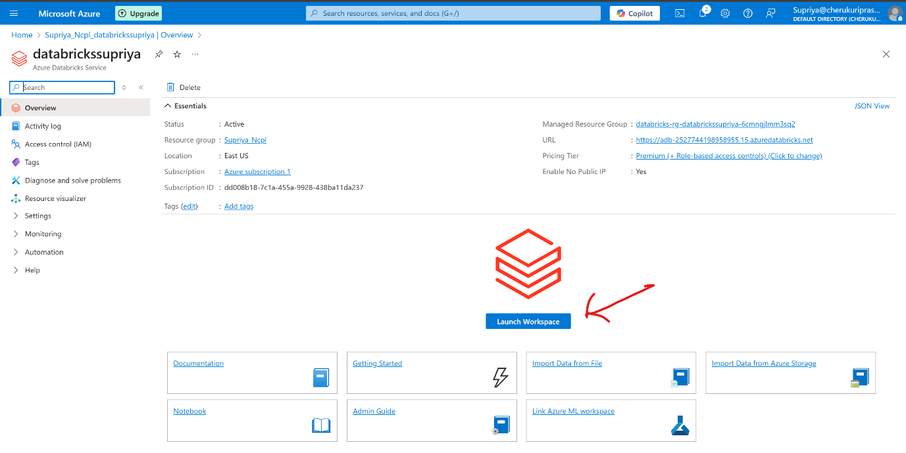

Page layout looks like this.

Workspace layout looks like this.

Recent shows what file are opened, what action is done.

Catalag is like storage,where data is stored in tables.

Job&pipelines: here we can run pipelines.

Compute: it provide virtual machines in backend to run the code.

Marketplace: It is for external toolswhich we can inegrate.

SQl editor: catalog tables can be queried in SQL editor.

Queries : we can save our queries here.

Dashboards: we can create dashboards like Power BI here.

Genie it is used for asking questions.

Alerts:it will send alerts

Question history: It has all the queries.

SQL Warehouse :

JobRuns:

Data Ingestion:

Click on new to open note book.

To write code click on code , to add notes click on text , you can also make headings.

The languages that it supports are as below.

Explore dbutils

**What is dbutils?**

dbutils is a utility command set in Databricks that helps manage:

* File systems (dbutils.fs)
* Notebooks (dbutils.notebook)
* Widgets (dbutils.widgets)
* Secrets (dbutils.secrets)
* Jobs and runtime information (dbutils.jobs, dbutils.entry_point, etc.)

| **Command** | **Use Case** |
| --- | --- |
| dbutils.fs | Interact with the DBFS (Databricks File System): list files, copy, move, delete. |
| dbutils.widgets | Create input widgets in notebooks (dropdown, textbox). |
| dbutils.notebook | Call or chain notebooks, pass parameters. |
| dbutils.secrets | Securely access secrets from a key vault. |
| dbutils.library *(legacy)* | Used to install libraries (now replaced by %pip or cluster libraries). |

Here’s a complete list of **dbutils** modules and subcommands available in **Databricks**, along with a brief description of each:

**🔹 Top-Level dbutils Modules**

| **Module** | **Description** |
| --- | --- |
| dbutils.fs | File system utilities for interacting with DBFS (Databricks File System). |
| dbutils.widgets | Create input widgets (text, dropdown, etc.) to parameterize notebooks. |
| dbutils.notebook | Run and chain notebooks, pass and retrieve parameters. |
| dbutils.secrets | Access secrets stored in a secret scope (like credentials). |
| dbutils.library | Legacy method to install libraries (replaced by %pip). |
| dbutils.jobs | Information about the job context (e.g., job run ID). |
| dbutils.entry_point | Access the current notebook's entry point for advanced use. |
| dbutils.credentials | Manage credential passthrough (used in secure access). |
| dbutils.data | Access datasets used in notebooks (less commonly used). |
| dbutils.help() | Lists available dbutils modules and commands. |

**Details of Common Modules**

**1. dbutils.fs — File System Commands**

| **Command** | **Description** |
| --- | --- |
| ls(path) | Lists files in a directory. |
| cp(from, to, recurse=False) | Copies a file or directory. |
| mv(from, to, recurse=False) | Moves a file or directory. |
| rm(path, recurse=False) | Deletes a file or directory. |
| head(path, maxBytes) | Shows the first N bytes of a file. |
| put(path, contents, overwrite=False) | Writes text to a file. |
| mount(source, mount_point, extra_configs) | Mount external storage. |
| unmount(mount_point) | Unmount a storage location. |
| mounts() | List all mount points. |

**2. dbutils.widgets — User Inputs**

| **Command** | **Description** |
| --- | --- |
| text(name, defaultValue, label) | Create a text box. |
| dropdown(name, defaultValue, choices, label) | Create a dropdown. |
| combobox(name, defaultValue, choices, label) | Editable dropdown. |
| multiselect(name, defaultValue, choices, label) | Select multiple values. |
| get(name) | Get user input value. |
| remove(name) | Remove a widget. |
| removeAll() | Remove all widgets. |

**3. dbutils.notebook — Notebook Control**

| **Command** | **Description** |
| --- | --- |
| run(path, timeout_seconds, arguments) | Run another notebook. |
| exit(value) | Exit the current notebook and return a value. |

**4. dbutils.secrets — Secure Access**

| **Command** | **Description** |
| --- | --- |
| get(scope, key) | Get a secret value. |
| getBytes(scope, key) | Get a secret as bytes. |
| list(scope) | List all keys in a scope. |
| listScopes() | List all available secret scopes. |

**5. dbutils.jobs — Job Info**

| **Command** | **Description** |
| --- | --- |
| taskContext() | Returns info like job ID, run ID, task key. Useful in job debugging. |

**🛠️ To View Available Commands in Your Environment:**

If you're in a Databricks notebook, run:

dbutils.help()

To get help for a specific module:

dbutils.fs.help()

dbutils.widgets.help()